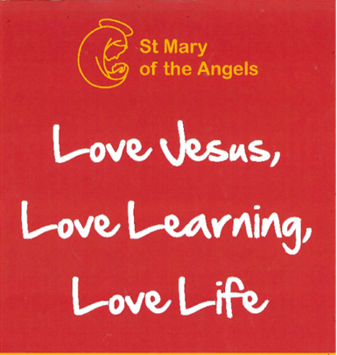
St Mary of the Angels Catholic Primary School
Handwriting Policy

This policy builds on the previous policy from Autumn 2022
It will be reviewed in Autumn 2025, or earlier if necessary

Intent
Handwriting is a skill which, like reading and spelling, affects written communication across the curriculum. Children must be able to write with ease, speed and legibility. Cursive handwriting teaches pupils to join letters and words as a series of flowing movements and patterns. The development of this fluid style when mastered allows children to apply their energy into the content of their writing as opposed to the formation of the letters themselves. Handwriting skills are taught regularly and systematically throughout the school.
At our school our aims in teaching handwriting are:

- To enable children to write in a consistent, well presented and legible format.
- To have a consistent, progressive and inclusive approach across Foundation Stage, Key Stage 1 and 2 when teaching handwriting.
- To ensure that from the Autumn Term of Year 2 to the end of Year 6 children are using a cursive writing style.
- To make sure all children know the difference between lower and upper case letters.
- To ensure the skills taught at Key Stage 1 continue to develop throughout Key Stage 2.

Implementation
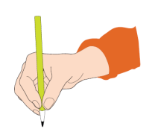
Children will be taught to hold a pencil correctly.

- Children should be encouraged to use a tripod pencil grip, where the pencil is gripped between the index finger and the thumb.
- The middle finger is then used to support the underside of the
- pencil as shown here:

Children should be encouraged to adopt the correct writing position as shown here (children who are left handed should reposition the paper the other way and sit to the left hand side if seated next to a right handed child)
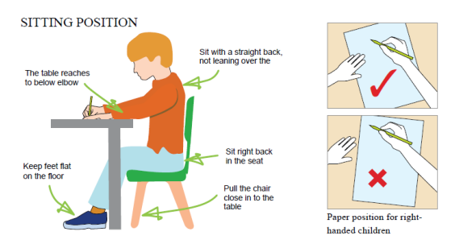
Children are also taught to:
- write from left to right and from top to bottom of the page
- start and finish letters correctly in a cursive style (from the Autumn Term of Year 2
- onwards)
- form regularly sized and shaped letters
- use regular spacing between letters and words
- take a pride in their written work and the overall presentation.

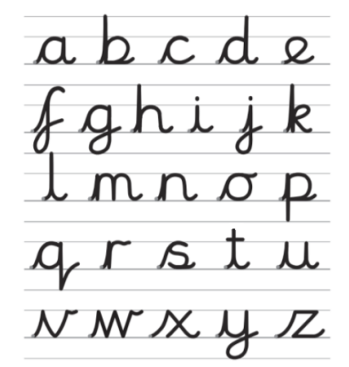

The cursive script agreed at St Mary of the Angels Primary School is shown here. This is taught from Autumn Term Year 2 onwards:

Left Handed writers
We recognise that children who are left-handed may need appropriate adaptations to support them, e.g. sitting on the left hand side of the table. We recognise that sometimes left-handed writers sometimes find letter formation more challenging and may need further adjustments or additional support.

EYFS

In EYFS children will be taught to form letters using the Twinkl phonics programme. Children are taught a pre-cursive print style. Every letter is taught through a matching mnemonic and a sequence of movements and images, to support learning retention.

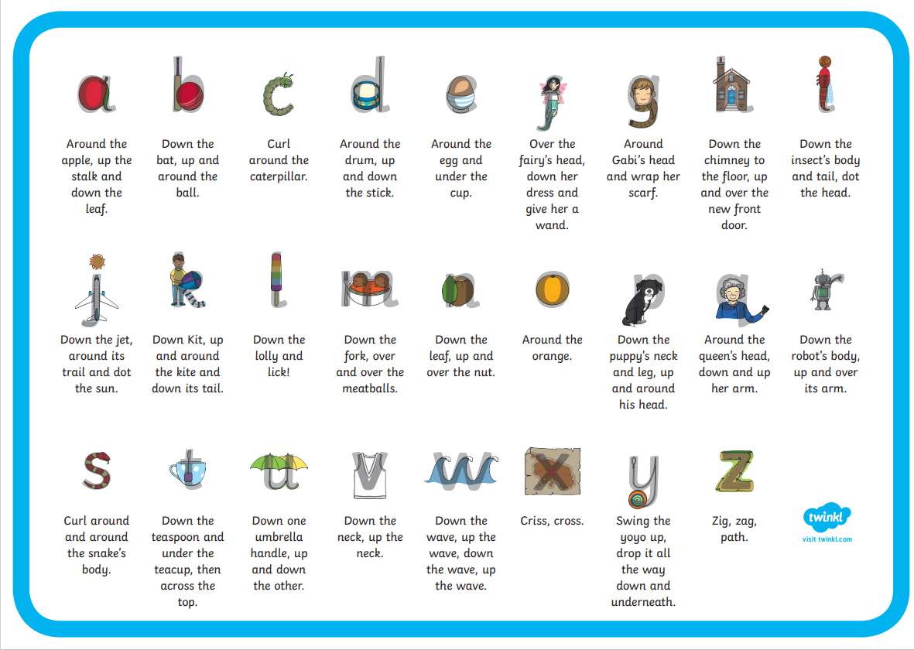
Letter formation is taught alongside phonic development. Our aim is that by the end of foundation
stage all children will be able to hold a pencil correctly, using the tripod grip and form all letters and numbers correctly. Errors in pencil grip and letter formation will be immediately addressed, modelled and corrected.

Children in EYFS use a mixture of blank and lined pages depending on the focus of the activity. Children are encouraged to practise letter formation through a range of opportunities including using white boards, chalks, paints, foam, sand trays, pens and pencils. These opportunities are both indoors and outdoors.

Key Stage One

In Key Stage 1, all children receive a taught daily handwriting session for 10-15mins. This may be cross-curricular.

In Year 1, during the Autumn Term pre-cursive print handwriting will be continued. During Year 1 there will be a continued focus on correct letter formation in print form in preparation for the introduction of pre-cursive flicks in the summer term.

Handwriting will be linked to phonic development, with the introduction of new sounds written in a pre-cursive print style during phonics lessons, to compliment the Twinkl presentation resources. Our aim is that by the end of Year 1 children will be forming all letters correctly and using a pre-cursive style.

In Year 2, adults will model cursive writing from the beginning of the year. The children will be
introduced to basic joins which they should transfer into all their independent writing. They will also continue to link their handwriting to their phonic development as they learn to write new sounds using a cursive writing style. By the end of Year 2 we strive to ensure that children have good letter formation and style using continuous cursive style.

Key Stage Two

In Key Stage 2 all children receive a daily handwriting session for a minimum of 10 minutes. This may be cross curricular.

In Year 3 children will continue to develop their use of continuous cursive handwriting building upon the skills they have developed in Key stage 1. In Years 4,5 and 6, children will be expected to use continuous cursive handwriting in all areas of the curriculum. From Year 4, children whose writing is neat and legible will use handwriting pens. If any child is not on track to reach these expectations, they will receive additional support through small group intervention.

We recognise that the skill of continuous-cursive can be unachievable for some children for different reasons. When this is identified, teachers will support children to develop a consistent, legible, well-formed style of writing within their capacity. These children can still progress to using a handwriting pen when their style is consistently well formed.

Handwriting Equipment

Children will use consistently sized lines in books from Year 1 onwards. During handwriting sessions
specific handwriting paper may be used. Children will also practise using the same sized lines as their other curriculum books so that children’s skills are transferable and that the same expectation of handwriting is set across all writing opportunities.

Children use a sharp HB pencil for all handwriting initially. In Year 4, when teachers assess that children are competent at joined handwriting they should be allowed to use a blue handwriting pen. In some cases, depending on the specific needs of individuals, children may use pencil grips or pens with a specific grip, or tripod ergonomic pencils.

Marking and Feedback

We emphasise constructive feedback. In our feedback policy we have clear systems for
feedback of children’s work which is adhered to throughout our handwriting sessions. In
handwriting sessions and during independent work it is important that incorrect pencil grip and
incorrect letter formation are both identified and corrected at the point it occurs. Children in KS2 use our ‘Writing non-negotiables’, which includes references to the expectations of handwriting to
ensure that their work meets expectations.

Impact

- Handwriting is a skill which affects written communication across the curriculum. Our aim is that children are able to write with ease, speed and legibility.

- By Year 6, children will use continuous-cursive handwriting using flowing movements and patterns. This handwriting should be demonstrated in all writing across the curriculum.

- Writing should be fluid in style to allow children to apply their energy into the content of their writing as opposed to the formation of the letters themselves.

