**Archive PE Blog 2023**

**May 2023**

This time it was the turn of our Year 3 boys football team to take part in the EFC Mini Kickers Tournament at Vauxhalls. All of the boys demonstrated excellent football and even better sportsmanship. We ended the afternoon having scored 24 goals and one of our boys even scored a hat-trick. A huge well done to all!

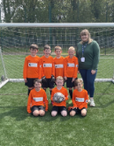

**April 2023**

Our Year 4 boys football team took part in the EFC Mini Kickers Tournament at Vauxhalls. They demonstrated great sportsmanship and determination and won three of their games. All of the boys were great ambassadors for St Mary's. A huge well done!

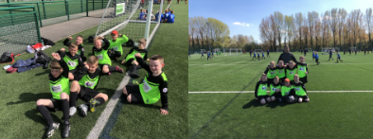

**March 2023**

Two children from each of our KS2 classes took part in an Inclusive Sports Festival at EPSV. The children were able to try out five sports (wheelchair basketball, table cricket, boccia, new age kurling and archery) all of which were completely new to our children. Our children represented St Mary's with wonderful attitudes and excellent sportsmanship as they made their way around different stations.

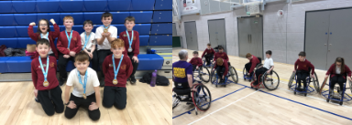

Our Year 3 class took part in the annual Ellesmere Port Schools Sports Partnership (EPSSP) Dance competition at the Civic Hall. They had a dance lesson each week for six weeks and then performed their routine at the Civic Hall, competing against 9 other schools. Our dance was to 'It's a Hard-Knock Life' from Annie. The children were absolutely incredible and made their teachers and parents so proud. The children finished 2nd overall - what a fantastic achievement!

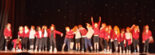

All of the girls in our school participated in a session of football skills led by a coach from Chester City FC. This was in support of the national schools campaign launched by the FA and Barclays, called #LetGirlsPlay. The afternoon was a huge success - and I think we might even have some Lionesses in the making!

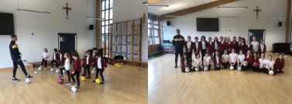

As part of the Hoops4Health programme, some of our Year 6's took part in a basketball tournament at EPSV. Although we didn't quite make it through to the final, all of our children showed some great basketball skills and fantastic defence. The children taking part embodied everything that a SMOTA representative does - determination, great sportsmanship and team spirit!

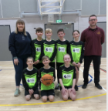

**February 2023**

We were fortunate to receive a visit from Cheshire Phoenix Basketball Club. Larry Austin Jr, Will Neighbour, Jamell Anderson and Tahjai Teague spoke to our KS2 children about their journies to becoming professional basketballers and some of the children were able to ask the players about their favourite players, moves and role models when growing up. We also learnt about Cheshire Phoenix's partnership with a community basketball programme in Uganda and the work which they do in community schools there. Our Year 6 class took part in the Hoops4Health programme, which included three stations delivered by the clubs' professionals: healthy eating, smoking cessation and basketball skills. We were broadcast live on BBC Radio Merseyside and covered in the local newsletter. You can also see a film clip that documents our enagement with Cheshire Phoenix here!

<https://www.youtube.com/watch?v=-lkDt9I3Kxs>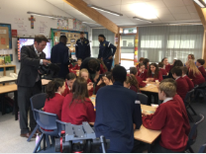

**January 2023**

Some of our girls from Years 4-6 took part in the SSP High-5 Netball Tournament. The girls showed great team-work and sportsmanship throughout the tournament and were a credit to our school.

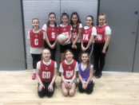

**December 2022**

During the last week of Autumn term, we hosted an intra-school dodgeball tournament for our children in Years 3-6. Miss Breen captained the green team to victory in the Year 3/4 tournament, the children demonstrated excellent team spirit and were all cheering on their friends in opposing teams. It was a double victory for green, as Mr Campbell captained the Year 5/6 winning team. A huge well done to all the children for showing such excellent resilience and sportsmanship throughout the tournament.

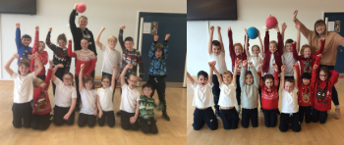

**November 2022**

Our Year 6 boys football team took part in the EFC mini-kickers tournament at Vauxhalls. The boys played outstandingly and scored 23 goals in just 5 games! They demonstrated some excellent skill and had great competitive spirit, being beaten only once, by the team who went onto win the tournament.

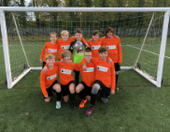

**October 2022**

This time it was the turn of some of our Year 3/4 children to attend the Rugby Festival. The children were commended for their fantastic attitude and enthusiasm throughout the afternoon and showed a real willingness to focus on developing their skills.

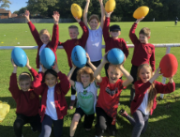

**September 2022**

Some of our Year 5 children were given the opportunity to attend a Rugby Festival at The Whitby Club. Children worked their way through a round-robin of tag-rugby activities. They had a wonderful afternoon and learnt lots of new skills!

