 | Rhythm | Pulse |  | Pitch
Y1 | - Copycat rhythm patterns  - Repeating rhythm patterns (ostinato  - Word-pattern chants Create, retain, perform own rhythm patterns | - Respond to the pulse in recorded/live music through movement and dance- Stepping, jumping/ tip-toeing  - Change the speed of the movement as the tempo of the music changes  - Play repeated patterns using body percussion, tuned and untuned classroom percussion (shake, scrape, tap) to maintain a steady beat |  | - High and low sounds.  - Explore percussion sounds to enhance storytelling,  - Follow pictures and symbols to guide singing and playing
Y2 | - Copycat rhythms  - Copy a leader, and invent rhythms for others to copy  - Create and perform chanted rhythm patterns  - Represent rhythm patterns using stick notation including crotchets quavers crotchets rests | - Walk in time to the beat of a piece of music or song.  - Recognise any changes in tempo (faster/slower)  - Begin to group beats in twos and threes by tapping knees on the first (strongest) beat and clapping the remaining beats  - Identify the beat groupings in familiar music that they sing regularly and listen to, e.g. in 2 Maple Leaf Rag by Joplin in 3 The Elephant from Carnival of the Animals by Saint-Saëns |  | - Singing games based on the cuckoo interval (so-mi)  - Respond to changes in pitch with actions (e.g. stand up/sit down, hands high/hands low).  - Recognise dot notation and match it to 3-note tunes played on tuned percussion
 | Performing |  | Notation
Y3 | - Develop facility in playing tuned percussion or a melodic instrument such as violin or recorder.  - Play and perform melodies following staff notation using a small range (e.g. Middle C–E/do–mi) as a whole class or in small groups.  - Individually copy back stepwise melodic phrases with accuracy at different speeds; allegro and adagio (fast and slow.). Extend to question-and-answer phrases.  - Listen to and correctly order phrases using dot notation, showing different arrangements of notes C-D-E/do-re-mi |  | 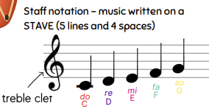  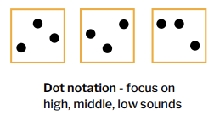  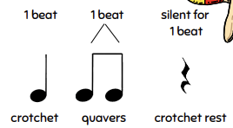
Y4 | - Develop facility in the basic skills of a selected musical instrument. This can be achieved through working closely with your local Music Education Hub who can provide whole-class instrumental teaching programmes.  - Play and perform melodies following staff notation using a small range (e.g. C–G/do–so)  - Copy short, melodic phrases  - Perform in two or more parts (e.g. melody and accompaniment or a duet) from simple notation using instruments played in whole class teaching. Identify static and moving parts. |  | 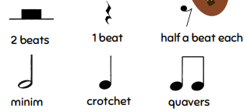  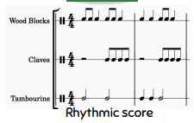  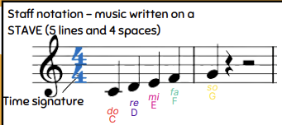
Y5 | - Play melodies on tuned percussion, melodic instruments or keyboards, following staff notation (note range C–C /do–do)  - Understand how triads are formed, and play them on tuned percussion / melodic instruments.  - Perform simple, chordal accompaniments to familiar songs (e.g. Yellow Submarine by The Beatles). G major / D major  - Perform a range of repertoire pieces and arrangements combining acoustic instruments to form mixed ensembles, including a school orchestra.  - Develop the skill of playing by ear on tuned instruments, copying longer phrases and familiar melodies |  | 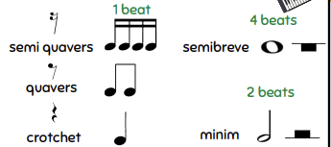  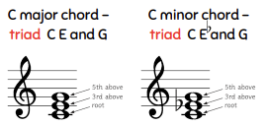  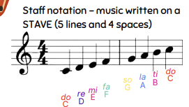
Y6 | - Play a melody following staff notation using notes within an octave range (do–do); make decisions about dynamic range, including very loud (ff), very quiet (pp), moderately loud (mf) and moderately quiet (mp).  - Accompany this same melody, and others, using block chords or a bass line. This could be done using keyboards, tuned percussion or tablets, or demonstrated at the board using an online keyboard.  - Perform a part within an ensemble - transition project! |  | 