Whole School English Long-Term Plan | Year 1 | Autumn 1 | Autumn 2 | Spring 1 | Spring 2 | Summer 1 | Summer 2
 |  | 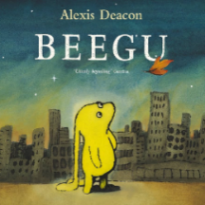 | 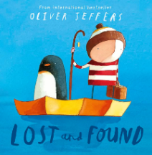 | 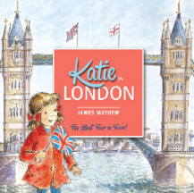 | 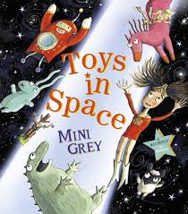 | 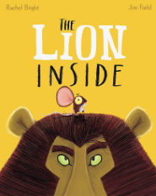 | 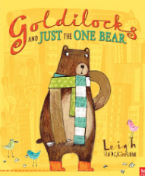
 |  | Beegu  Letter writing  Address writing  Narrative | Lost and Found  Labels  Character description  Narrative | Katie in London  Postcards  Non-chronological report | Toys in Space  Fantasy Story  Change part of a story | Lion Inside  Character description  Fact files  Changing part of a story | Goldilocks & Just The One Bear  Character description  Setting description  Biography
 | Year 2 | 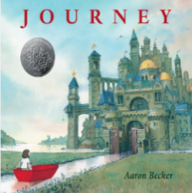 | 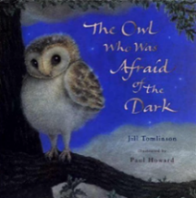 | 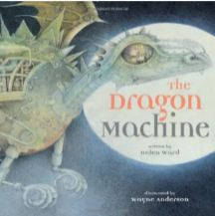 | 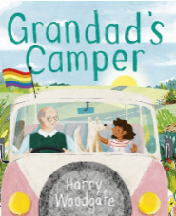 | 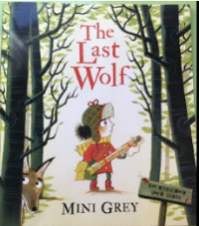 | 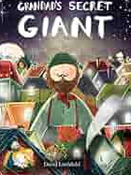
 |  | Journey  Narrative  Setting description | The Owl Who Was Afraid of The Dark  Non- Chronological report | The Dragon Machine  Diary entry  Narrative | Grandad’s Camper  Recount  Postcards | The Last Wolf  Persuasive writing  Minibeast poems | Grandad’s Secret Giant  Story with a moral focus  Diary entry
 | Year 3 | 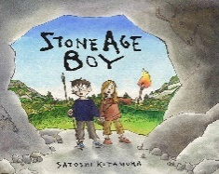 | 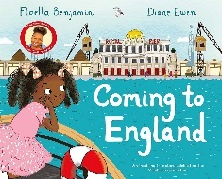 | 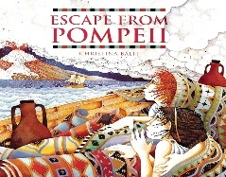 | 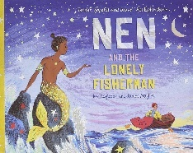 | 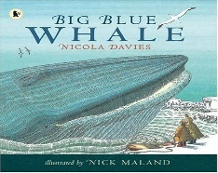 | 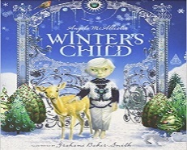
 |  | Stone Age Boy  Non-Chronological Report  Diary Entry  Instructions  Narrative | Coming to England  Letter Writing  Recount  Diary Entry  Leaflet | Escape form Pompeii  Narrative  Recount  Diary Entry  Letter Writing | Nen & the Lonely Fisherman  Fantasy  Diary Entry  Instructions  Poetry | Big Blue Whale  Leaflet  Poetry  Persuasive Poster  Oracy - Speaking | Winter’s Child  Fantasy  Poetry  Diary Entry
 | Year 4 | 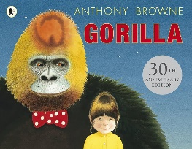 | 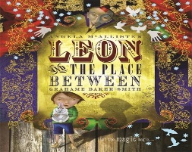 | 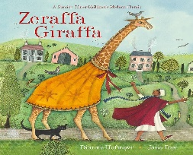 | 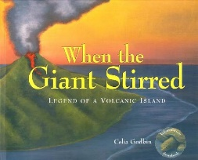 | 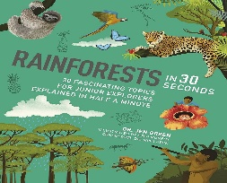 | 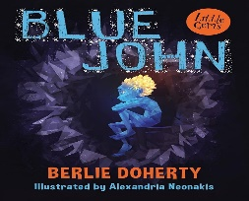
 |  | Gorilla  Narrative  Diary Writing  Information Text  Speech writing | Leon & The Place In Between  Diary Entry  Descriptive Characters  Letter Writing  Poetry | Zeraffa Giraffa  Persuasive Leaflet  Letter Writing  Recount  Debates | When the Giant Stirred  First-Person Narrative  Descriptive Settings  Diary Writing  Information Text | Rainforests In 30 Seconds  Point of View  Oracy – Speaking  Factual Writing | Blue John  Explanation Text  Descriptive Writing  Instructions  Narrative
 | Year 5 | 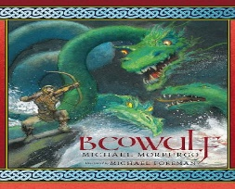 | 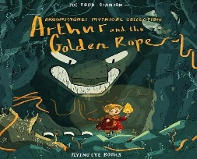 | 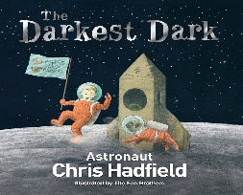 | 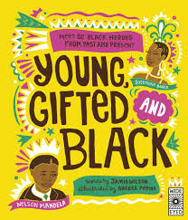 | 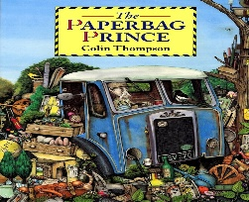 | 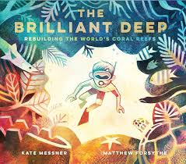
 |  | Beowulf  Myths & Legends  Diary Writing  Narrative  Letter writing | Arthur and the Golden Rope  Myths & Legends  Narrative  Oracy – Speaking & Listening | The Darkest Dark  Biographical writing  Formal tone  Report writing | Young, Gifted and Black  Diary Writing  Narrative  Report writing | The Paperback Prince  Persuasive leaflet writing  Letter writing  Debates | The Brilliant Deep  Information text  Formal tone  Reporting writing
 | Year 6 | 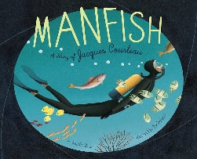 | 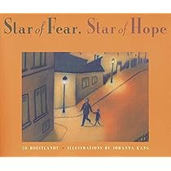 | 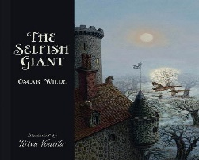 | 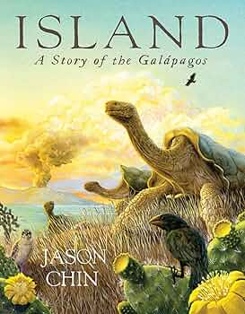 | 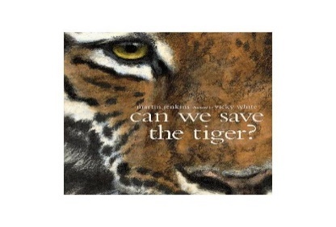 | 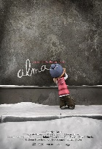
 |  | Manfish  Recount writing  Diary writing  Biographical writing  Poetry | Star of Fear, Star of Hope  Narrative writing  Diary writing  Letter writing  Dialogue | The Selfish Giant  Narrative writing  Formal tone  Persuasive writing  Report writing | Island: A Story of Galapagos  Recount writing  Biographical writing  Poetry | Can We Save the Tiger?  Persuasive writing  Letter writing  Debates  Information text | Alma  Recount writing  Narrative writing  Dialogue

