St Mary of the Angels Catholic Primary School
Enrolment Application
Programme of Sacramental Preparation 2022-2023
Child’s name: …………………………………………
Parent’s name: …………………………………………

Date of Baptism: ……………………………………….…………………………..
Parish of Baptism: …………………………………………………………………..
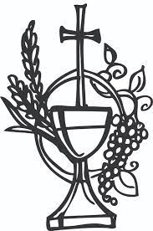
- I wish to enrol my child ……………………….. on the programme of preparation to receive the sacraments of First Reconciliation and First Eucharist.
- I am willing to engage with and fully support the programme.
- I am willing to support my child with their faith journey

Signed: ………………………………………………………………………………………..………
Relationship to child: …………………………………………………………………………..

